THE DEPARTMENT

The Princeton Police Department was formed on January 1, 2013, when the Borough of Princeton and the Township of Princeton consolidated forming one Princeton. The consolidation of the Princeton’s also included the former Borough and Township Police Departments merging into one Police Department, The Princeton Police Department. The Princeton Police Department has a very diverse compliment of highly qualified officers, many of whom have earned bachelor’s and master’s degrees.

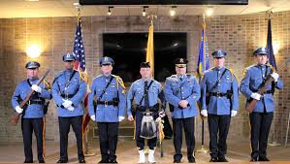

CANDIDATE CRITERIA
Candidates who successfully pass an initial oral interview will be subject to a physical fitness test. Selected candidates will also undergo a further series of interviews and an intensive background investigation. The testing process is open to candidates who will meet the following criteria upon appointment:
Between 18 and 35 years of age

Citizen of the United States

New Jersey resident at the time of appointment

Possess a valid New Jersey driver’s license at the time of appointment

Possess an Associates Degree, 60 college credits or 4 years of active military service

Vision no more than 20/100 in each eye, corrected to 20/20 in each eye

Normal hearing in both ears

Good physical condition

Good moral character

Able to swim

Able to distinguish colors

Additionally, we are looking for candidates who are intelligent, possess good writing skills, good verbal communication skills, like to work with people to solve community problems, are self-starters, and are self assured, positive thinking persons.

PRINCETON

POLICE

DEPARTMENT

1 Valley Road
Princeton, NJ 08542
Chief Christopher Morgan
www.princetonnj.gov/departments/police-department
PRINCETON POLICE DEPARTMENT PROFILE
The Princeton Police Department is organized by the separation of three Divisions: Operations, Investigative and Support Services. Within these divisions are the Patrol Bureau, Detective Bureau, Traffic Bureau, K9 Bureau, Records Bureau and Safe Neighborhood Bureau. The Department has identified itself as a service oriented police department and participates in many community functions to include Community Night Out and the Youth Police Academy.

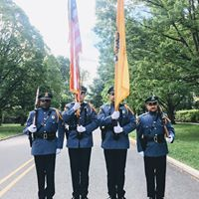

JOB OPPORTUNITIES
The Princeton Police Department is looking for qualified applicants for the position of patrol officer. The department offers a wide array of benefits for men and women who desire a career in law enforcement. If you are interested in the opportunity to become a member of “Princeton’s Finest”, please apply now. You may complete your application online at www.policeapp.com.
A fee is required upon application to cover the costs of the hiring process and study guide.

PRINCETON IS AN

EQUAL

OPPORTUNITY EMPLOYER

EOE-M/F/V/H

FACTS ABOUT PRINCETON
Princeton is a historic town situated in central New Jersey midway between Philadelphia and New York City. Settled in the 1690’s, Princeton is known for its natural beauty and accessibility to metropolitan centers. Princeton is a college town and is the home of Princeton University, Rider University-Westminster Choir College Campus, and the Princeton Theological Seminary.
Princeton has a diverse residential population of approximately 30,000 residents housed within its 18.1 square miles. The hub of Princeton is its bustling central business district featuring many fine shops, restaurants, and coffee shops. Residents are enriched by the many cultural activities that occur on the Princeton University campus and at McCarter Theater. Princeton University also hosts many NCAA Division I athletic events throughout the year.
