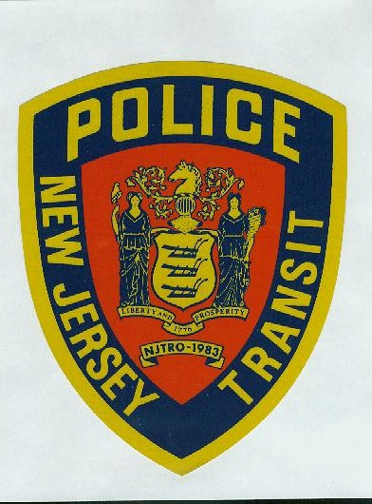

**NJ TRANSIT**

**Police**

**Accepting Applications On:**

**Age:**

Candidates must be at least 21 years old on the date of the physical examinationand **not** have reached their 35th birthday at the time of appointment to the Police Academy Training Program (“PTC”); unless covered by the PTC age requirement guideline New Jersey Statute; N.J.S.A. 43:16A-3.

**Citizenship:**

Candidates must be citizens of the United States on the date of submitting application, and never have renounced United States citizenship**.**

**Driver’s License:**

Candidates must have a driving record in good standing and valid motor vehicle driver’s license on the date of application submission.

**Education: (Achieved by 5/29/20)**

* A Bachelor's degree; or
* Sixty (60) college credits from an accredited institution, plus one (1) year of full-time or part-time experience as a first responder (e.g. Paramedic/EMT/Class I/Class II/Police Dispatcher/ Corrections/or related); or
* Thirty (30) college credits plus at least two (2) full years of continuous active duty military service with an honorable discharge.

**Requirements**

**February 24th at 9 AM**

Visit PoliceApp.com on **February 24, 2020 at 9AM** to apply for the upcoming NJ TRANSIT Police Department Test. You can only apply for the test via PoliceApp.com. There will be a **non-refundable** $25 application fee to apply for the test. The first **1500 applicants** will be considered and will be contacted via PoliceApp.com regarding the details of the Physical Qualification Test, which will be held the weekend of **April 4 and April 5.**

When applying on PoliceApp.com, please be prepared to upload the following documents:

* Resume
* Unofficial or Official College Transcript or Degree

(must include name of applicant and name of school)

* DD214 (long form if applicable)

Please visit njtransit.com/police for information regarding the NJ TRANSIT Police.

Email [NJTPD_ExamQuestions@njtransit.com](mailto:NJTPD_ExamQuestions@njtransit.com) if you have any additional questions.



NJ TRANSIT is an Equal Opportunity Employer

**To be considered for a NJ TRANSIT Police Officer, you must meet all the necessary requirements. Failure to provide appropriate documentation that demonstrates fulfillment of these requirements on the date of application submission, will result in no further consideration for the Police Officer selection process.**