njwle presents:  firearm training  When  March 12, 2019  12 – 4pm  Where  RTSP  961 Route 10 East Unit 2F  Randolph, NJ 07869  Taught by certified RTSP Range Instructors  https://www.njwle.org/  https://www.rtsponline.com/ | 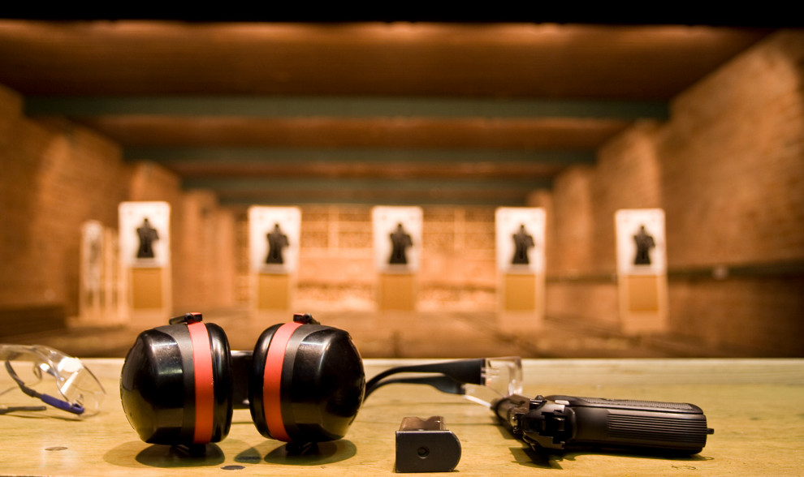  njwle members:  $25.00  non-members:  $35.00  PLEASE BRING 500 ROUNDS OF AMMUNITION PER ATTENDEE  TO REGISTER:  REGISTRATION FORMS CAN BE FOUND AT NJWLE.ORG UNDER RANGE  PLEASE FILL OUT AND E-MAIL THE REGISTRATION TO NJWLE@YAHOO.COM  DEADLINE TO REGISTER IS MARCH 1ST

