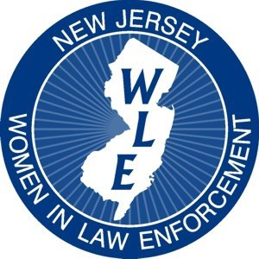
New Jersey Women in Law Enforcement Presents:

15th Annual Leadership Training

Conference and Awards Ceremony
Co-Sponsored by Monmouth University

Understanding Addiction

May 23, 2019
8:15 AM—4:00 PM
(Registration with continental breakfast begins at 8:15 a.m. and presentations will begin promptly at 9:00 a.m.)

SPEAKERS
Retired Sergeant Danielle Lo Russo, 25 years in Law Enforcement
Richard (In Long Term Recovery) City of Angels/Center for Family Services
Dr. James Baird, Jefferson Washington Township Hospital
Tony Luke, Jr., A Father’s Loss, Grief Recovery Specialist
Michele Perez, Recovery Coach Professional/Interventionist, City of Angels

TO BE HELD AT:
Monmouth University, Rebecca Stafford Student Center, Anacon Hall-2nd Floor
400 Cedar Avenue
West Long Branch, NJ 07764

https://www.monmouth.edu/map/

$75.00 Registration
(includes full day of training, continental breakfast and lunch)

Name: Rank:

Agency:

Are you a NJWLE Member? Yes No
Is this your first NJWLE conference? Yes No
Has your rank changed since last NJWLE Conference?Yes No

Address: City/State/Zip: Are you a previous NJWLE Award recipient? Yes No

E-Mail & Phone Number:

You may scan registration form and pay through PayPal or
Make checks payable to: NJWLE Training Conference
New Jersey Women in Law Enforcement
3817 Crosswicks Hamilton Square Road
Suite 157 Hamilton, NJ 08691
(Purchase Orders accepted)
For further information or to register online, please visit our website at: www.NJWLE.org
Or contact Detective Danielle Oliveira, at NJWLE@yahoo.com
NJWLE is a 501(C)6 Non-Profit Organization

